Info About API-5CT Coupling
- Couplings are short pipes with internal threads, used to connect two joints of tubing or casing.
- Role: Casing/Tubing Connection
- Application Scenarios: Down hole Drilling & Oil & Gas Production
- Standard：API 5CT & API 5B
- Production process: Saw Cutting, Machining Threading, Marking,
Phosphate, Coating, Packing.
- Coupling Grade Colour Code: To distinguish different grades of steel.
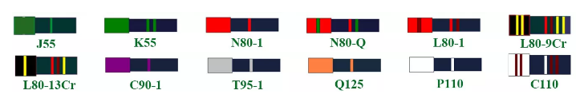
- The meaning of grade designations:
“J/K/N/L/C/T/Q/P”---- Different properties
“55/80/90/95/125/110”---- Yield strength specification
- Common steel grades in the United States：J55,K55,L80,P110
- Package: By carton, wooden case, wooden pallet, or as customer's requirements.
- Data Sheet: Find out the dimensions, tolerances, and mass of couplings as specified in the API 5CT standard.

1.Casing Coupling
Size: 4-1/2” to 20”
Thread Type: STC - Short Round Thread
LTC - Long Round Thread
BTC - Buttress Thread
Grade: J55, K55, L80, N80-1, N80-Q, C90, T95, C110, P110, Q125
SCC: Special Clearance Coupling
Its internal space is slightly larger than that of standard couplings, allowing smooth connection even when the outer wall of the casing has a coating or slight deformation.
BBE: Bevel Both End
The two end edges of the coupling are beveled, which prevents casing scratches during installation and eases casing insertion.
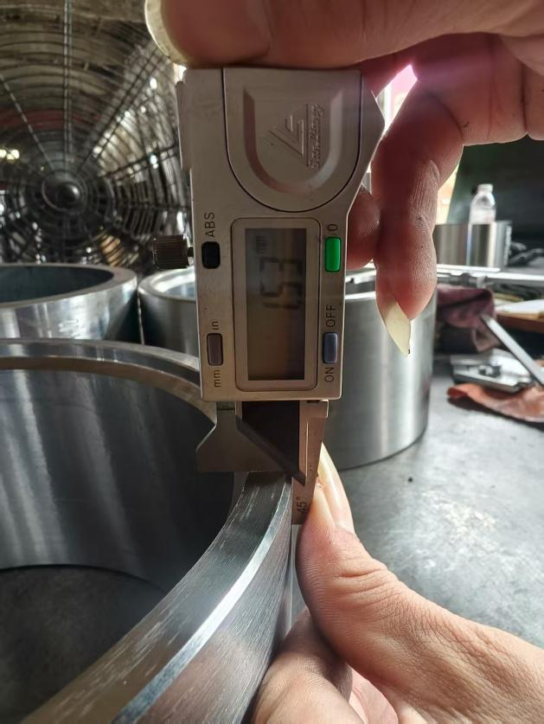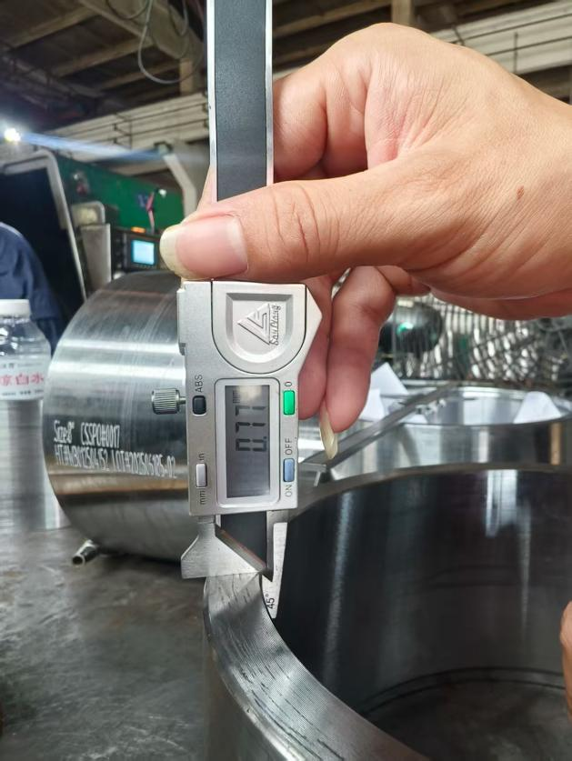
Internal Chamfer Measurement External Chamfer Measurement

Pictures Of Casing Coupling：
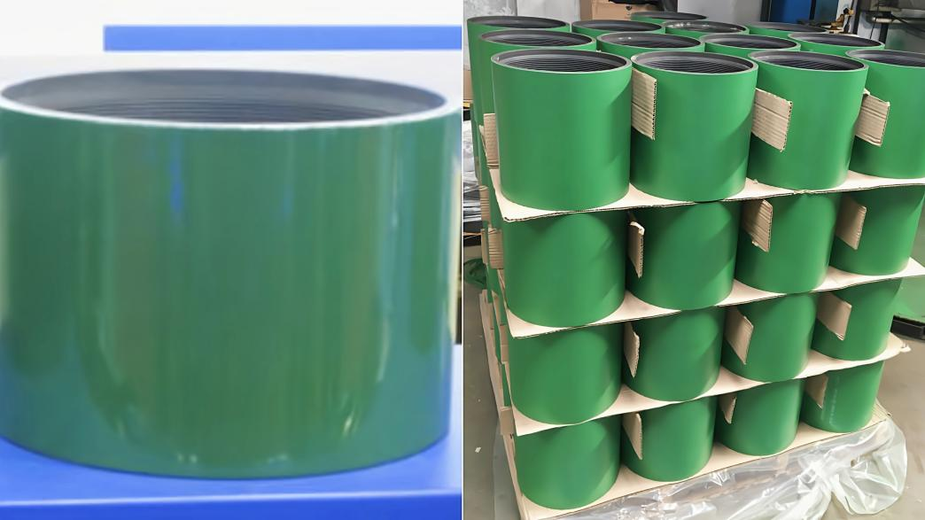
① Size:9-5/8” Grade:K55 Thread:BTC
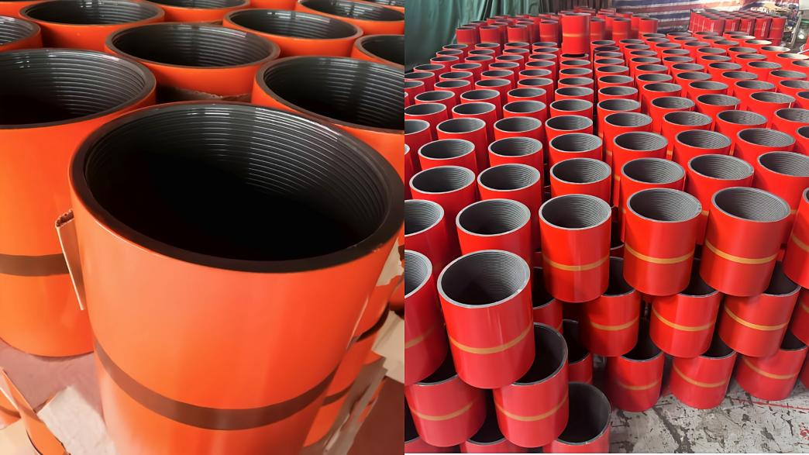
② Size:7-5/8” Grade:L80 Thread:BTC
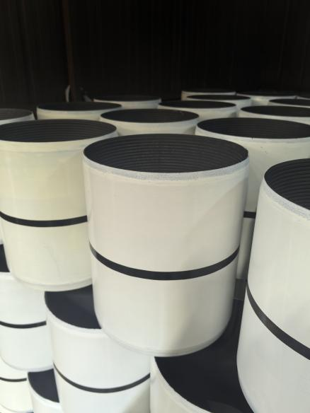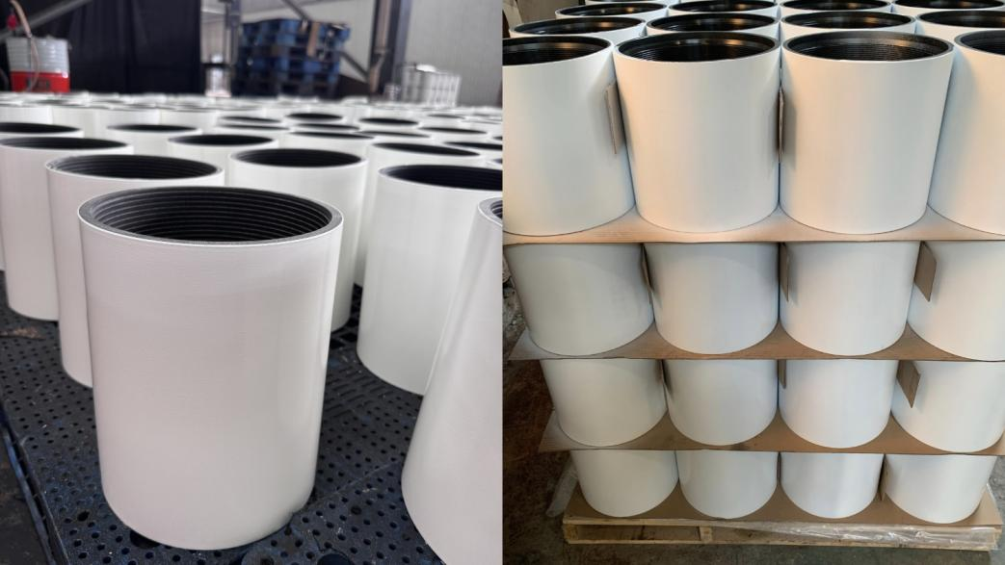
③ Size:8-5/8” Grade: P110 Thread: BTC SCC

2.Tubing Coupling
Size: 1.050” to 4-1/2”
Thread Type: EUE - External Upset End
NUE - Non-Upset End
Grade: J55,K55,L80,P110,13Cr
Pictures Of Tubing Coupling：
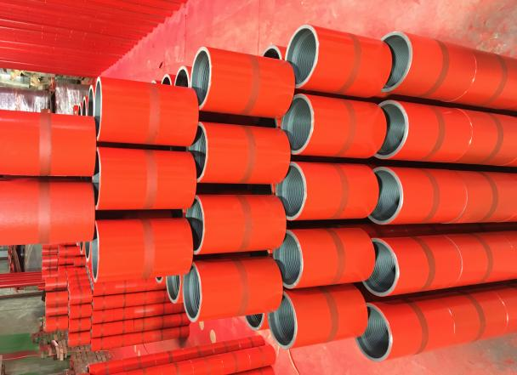
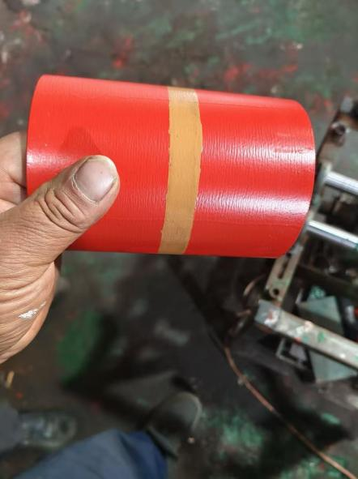

④ Size:2-7/8” Grade:L80 Thread:EUE
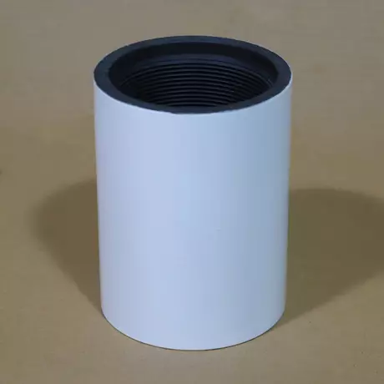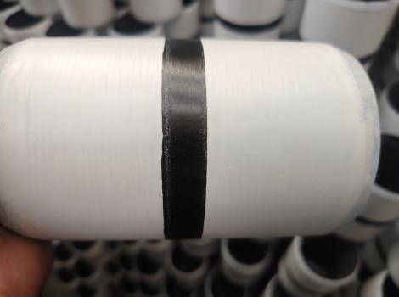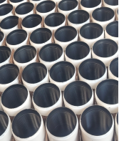
⑤ Size:2-7/8” Grade:P110 Thread:EUE SCC

